September 2022 – SAMPLE TAG EMAIL

Hello John,

We understand from one of our USANA Associates, Jane Smith, that you are giving consideration to joining our USANA team.

If your personal goals include financial freedom, true health, and the time to enjoy them, while helping others do the same, then you are taking a significant step in the right direction by taking a close look at USANA.

First, a little bit about us:

My name is Pete Zdanis. My wife Dora and I have been full-time USANA Associates for the past 26 years.

Our successful USANA team members include entrepreneurs, estheticians, teachers, realtors, nurses, business executives, athletes, dentists, psychologists, retirees, dieticians, health coaches, government employees, NPC fitness models, contractors, insurance agents, current and former military members, computer analysts, nutrition counselors, podiatrists, health system workers, office managers, business owners, wedding planners, laboratory assistants, receptionists, restaurant workers, hospital workers, chiropractors, yoga and Pilates instructors, scientists, massage therapists and many others from all walks of life.

However, the most important person here is YOU:

If you want to take control of your future, you owe it to yourself, and those you care about, to learn everything you can about USANA.

We are ready, willing and able to help guide you on your road to success with USANA.
Following are some links that we think you will find to be of interest:

- USANA Fact Sheet – Answers the question: What, exactly, IS USANA?
- About USANA – All the information you need in one document.
- USANA Vitamins Guidebook – Everything you need to choose the right supplement
- International Recognition – It only makes sense to work with a USANA leader, and sponsor, who knows how to show you to succeed.
Thank you for taking the time to review this information.

In closing, if you remember nothing else about us or USANA, just remember two things:

- We have been full-time USANA Associates for the past 26 years
- Our ONLY incentive is for you and your sponsor to become successful in USANA

That should make your next decision very easy.

Best regards,

Pete and Dora

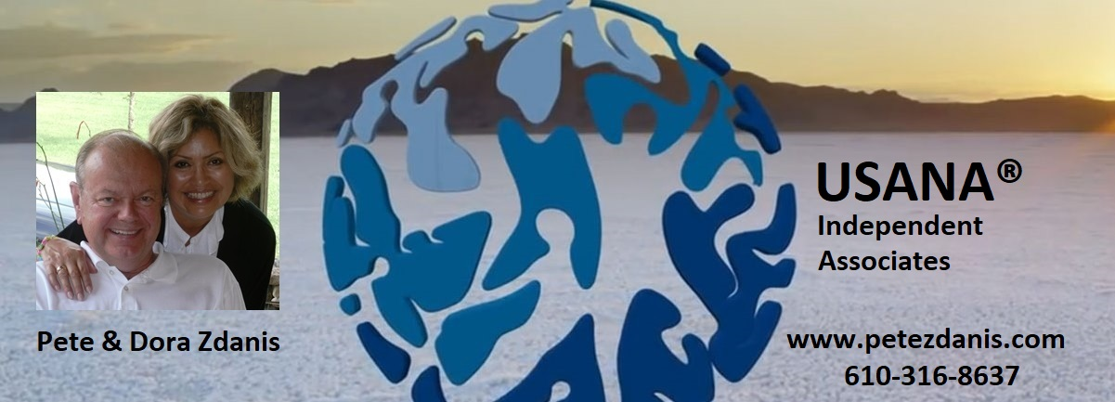

Pete and Dora Zdanis
USANA Inaugural Foundation Executive Diamonds
New Smyrna Beach, FL
www.petezdanis.com – www.thezdanisstory.com
Voice/Text: 610-316-8637



