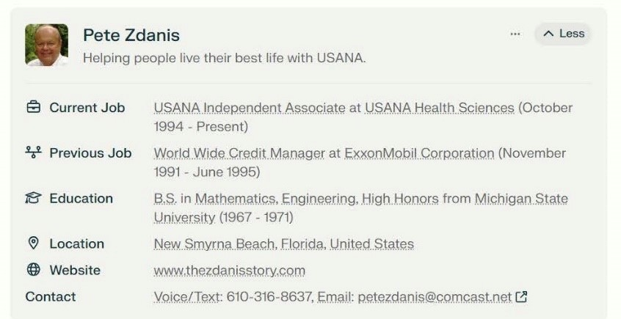

Pete Zdanis is a successful USANA Health Sciences independent associate who has built a large organization over nearly 30 years with the company. Here are some key details about Pete Zdanis and his USANA business:
- Pete and his wife Dora have been USANA associates since October 1994, making them some of the earliest and longest-tenured associates with the company.
- They have built an organization of over 14,000 USANA associates and preferred customers across 18 countries.
- Pete and Dora are 1-Star Diamond Directors with USANA, which is one of the highest ranks in the company.
- They have consistently been among USANA's top 20 income earners for over 25 years.
- In 2014, Pete and Dora were recognized as Foundation Executive Diamond Directors, an honor given to only about 40 associates out of hundreds of thousands worldwide at that time.
- Prior to USANA, Pete had a 25-year corporate career with ExxonMobil, rising to senior executive positions before being downsized.
- Pete and Dora use their experience to mentor and train other USANA associates, helping many build successful businesses of their own.
- They are based in New Smyrna Beach, Florida and continue to actively build their USANA business while supporting their large team.
- Pete provides extensive training resources and tools to help his team members succeed with USANA.
Overall, Pete and Dora Zdanis are considered to be some of the most successful and influential Independent Associates in USANA's history, having built a large, long-lasting organization and helping many others find success with the company as well.
Source: Perplexity.AI Information Search – Copyright © 2024 – All Rights Reserved

